Original Article Open Access Journal

A Short Review on Vaccine Barriers In Afghanistan
Ahmad Khan, MD, MS¹ , Ferishta Rahimi², Ulfatullah Malak³, and Madina Qazizai⁴
Abstract
In preventive medicine, vaccines are critical to decreasing the burden of vaccine-preventive diseases. In the last few decades, vaccines have decreased the mortality rate among children, and vaccine coverage has improved. On the other hand, in lower-income countries like Afghanistan, sustainable immunization is still challenging for various reasons. It is essential to investigate the potential barriers locally, such as vaccine hesitancy and other factors, to build up local evidence to formulate effective policies. However, the number of studies on vaccination is limited in lower-income countries like Afghanistan.
In Afghanistan, a small number of studies have been conducted on the phenomenon of COVID-19 vaccine hesitancy, and it is not feasible to determine from conducted study results if people have the same level of hesitancy toward other vaccines, or if the present rumors and myths about the COVID-19 virus impacted people's perception of the COVID-19 vaccine. The purpose of this short review is to elaborate on the potential barriers to vaccine programs in lower-income countries like Afghanistan and suggest future studies to build up local evidence to appropriately fill in the gaps to sustain vaccine programs and prevent the burden of vaccine-preventable diseases in the country.
Keywords: vaccine, hesitancy, developing countries, barriers
Copyright: © 2021 The Authors. Published by Medical Editor and Educational Research Publishers Ltd. This is an open access article under the CC BY-NC-ND license (https://creativecommo ns.org/lic enses/by-nc-nd/4.0/).
¹A T Still Health Sciences University
^{2,3,4}Afghanistan Open University Organization

Introduction

In medicine, use of vaccines is an effective and successful way to decrease the burden of several infectious diseases considerably in lower- and middle-income countries (Carter et al., 2023). Annually, vaccines prevent approximately 5.1 million deaths in lower- and middle-income countries like Afghanistan (Carter et al., 2023). According to Li et al. (2021), in the last two decades, vaccines have saved 36 million children's lives in lower and middle-income countries.
Even though several global initiatives in the last two decades, including the United Nations Development Goals, Global Vaccine Action Plan, and Vaccine Alliance, have remarkably improved vaccine coverage, around 14 million infants did not receive the first dose of diphtheria-tetanus-pertussis vaccine in 2019 (Cata-Preta et al., 2021), and the burden of mortality and morbidity from vaccine-preventable diseases is still substantial in lower-middle-income countries like Afghanistan due to lower coverage of infant vaccination (Turner et al., 2018). Around 1.5 million children under the age of five lose their lives to diseases that are preventable with vaccines, and the number of deaths is higher in South Asian and Sub-Saharan African countries (Our World Data, 2018). See Figure 1

Figure 1
Number of Deaths from Vaccine Preventable Disease in 2019 in Lower-and-middle Income Countries
Source: Our World in Data (n.d.). Deaths caused by vaccine-preventable disease, World, 2019. https://ourworldindata.org/grapher/deaths-caused-by-vaccine-preventable-diseases-over-time?time=latest.

Determinants Impacting Vaccination Coverage
In lower- and middle-income countries like Afghanistan, generally, three determinants can impact vaccination coverage, and Phillips et al. (2017) highlighted these three determinants as acceptability, accessibility, and availability of vaccination. Several study results indicated that lower-income countries like Afghanistan have challenges with making the vaccine available and accessible at a national level. Disruption in the availability and accessibility of vaccination can lead to poor vaccination sustainability and coverage and negatively impact the efforts to prevent mortality and morbidity of vaccine-preventable diseases (Burnett et al., 2018; Gooding et al., 2019; Sato, 2020).
Vaccine Hesitancy
Even though there is no universal definition for vaccine hesitancy, the World Health Organization (2019) states that vaccine hesitancy is a condition considered one of the ten threats to health where an individual is unwilling to get a vaccine or delays vaccination for various reasons. Vaccine hesitancy is a complex issue, and several factors, such as culture, personal beliefs, and time, can influence it (MacDonald et al., 2015).
Abu El Kheir-Mataria et al. (2023) highlighted that research on vaccine hesitancy is limited in lower- and middle-income countries like Afghanistan, and they indicated in a meta-analysis that there is one study conducted in lower-income country and two studies in lower-middle-income countries on COVID-19 vaccine hesitancy. See Table 1.

Table 1
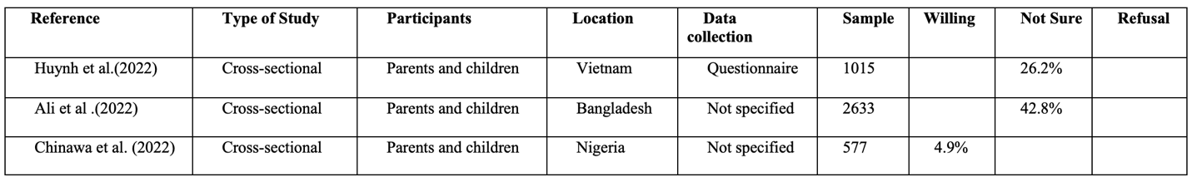
Studies on COVID-19 Vaccine Hesitancy in Lower- and Middle-Income Countries
Source: Abu El Kheir-Mataria, W., Saleh, B. M., El-Fawal, H., & Chun, S. (2023). COVID-19 vaccine hesitancy among parents in Low- and Middle-Income Countries: A meta-analysis. Frontiers in Public Health, 11, 1078009. https://doi.org/10.3389/fpubh.2023.1078009.

MacDonald et al. (2015) suggested that a workable universal strategy does not exist to improve vaccine acceptance in various cultures. Study results highlighted that a better solution is to build up local evidence and find out sociocultural, individual, and political influential factors that negatively impact vaccine acceptance in the community (Larson et al., 2014). In several international studies, influential factors that lead to vaccine hesitancy are a lower level of health literacy, previous adverse effects of vaccination, fear, lack of trust, and exposure to false information on vaccines (Cobos Muñoz et al., 2015; Rainey et al., 2011; Sridhar et al., 2014).
Vaccination Accessibility and Availability
According to the United Nations Development Program (UNDP), in the world, allocation and distribution of vaccines are attributed to political, health-related matter, diplomatic, and economic factors. Lower- and middle-income countries like Afghanistan's access to vaccines is slower, which makes people there vulnerable to vaccine-preventive diseases (UNDP, n.d.).
Also, purchasing vaccines puts lower- and middle-income countries like Afghanistan in significant financial burden. According to the Global Health Expenditure Database, Afghanistan spent 15.3 % of its gross domestic product (GPD) on the health system in 2020 (World Health Organization, 2020). Lower-income countries like Afghanistan need to increase their health expenditure by 56.5% to provide vaccine coverage for 70% of their population, while higher-income countries need to increase their health expenditure by 0.8% to reach the same level of coverage (UNDP, n.d.). See Figure 3.

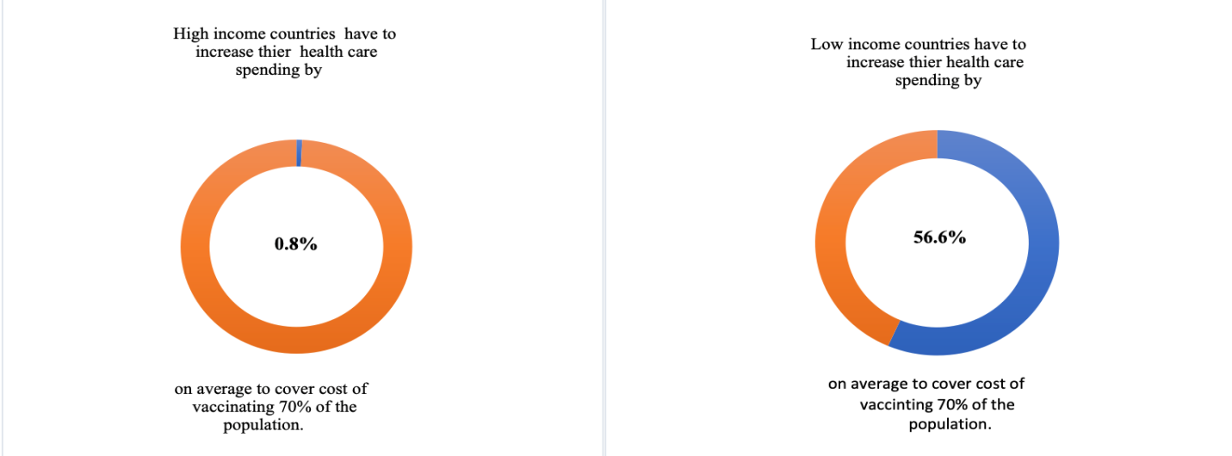
Figure 3
Comparison Health Expenditure of Lower-income Countries to High-income Countries of Vaccinating 70% of the Population
Source: United Nation Development Program (n.d.). What is vaccine equity? https://data.undp.org/vaccine-equity/.

Vaccine Hesitancy in Afghanistan
Even though studies are limited on vaccine hesitancy in Afghanistan besides on COVID-19 vaccine, as in other cultures in Afghanistan, peoples’ perceptions toward COVID-19 vaccines are influenced by the myths, rumors, and misconceptions on COVID-19 vaccine (Nemat et al., 2021); study results suggested potential reason for COVID-19 vaccine hesitancy as vaccine quality, efficacy, and potential side effects.(Abu El Kheir-Mataria et al., 2023).
Abu El Kheir-Mataria et al. (2023), in a meta-analysis of cross-sectional studies on COVID-19 vaccine hesitancy, indicated that 49% of parents were willing to get the COVID-19 vaccine for their children in three lower- and middle-income countries. Moreover, in Afghanistan Nemat et al. (2021) indicated in cross-sectional study that 37% of the population hesitated to take the COVID-19 vaccine because of safety and quality concerns in different province. Sallam (2021) indicated that it is hard to determine if people are hesitant only toward the COVID-19 vaccine because of myths and rumors or if they have the same degree of concerns about other vaccines as well.
Suggestion and Gaps in the Literature
In Afghanistan, the number of studies on vaccine hesitancy is limited. It is crucial to perform large-scale studies to include populations from different cultures and educational backgrounds to investigate the barriers of vaccines and people’s perceptions on vaccines. Currently, several studies are conducted on a smaller scale on populations with specific characteristics, such as access to an online survey on the COVID-19 vaccine. The level of biases and limitations in the study results make it harder to determine if people have the same hesitancy toward other vaccines or if it is just the COVID-19 vaccine.
Conclusion
In lower- and middle-income countries, vaccines can decrease the financial burden and mortality and morbidity of vaccine-preventable diseases. It is essential to study locally the barriers to vaccine sustainability programs in Afghanistan to address them appropriately. Currently, the level of evidence of barriers to vaccine programs is substantially limited in Afghanistan, beside a few studies on COVID-19 vaccine, which makes it challenging for policymakers to formulate policies to address the barriers and improve the coverage of vaccination at a national level.
References
- Abu El Kheir-Mataria, W., Saleh, B. M., El-Fawal, H., & Chun, S. (2023). COVID-19 vaccine hesitancy among parents in Low- and Middle-Income Countries: A meta-analysis. Frontiers in Public Health, 11, 1078009. https://doi.org/10.3389/fpubh.2023. 1078009.
- Ali, M., Proma, T. S., Tasnim, Z., Islam, M. A., Urmi, T. A., Ahmed, S., Sarkar, A. S., Bonna, A. S., & Khan, U. S. (2022). Parental COVID-19 vaccine hesitancy for children with neurodevelopmental disorders: a cross-sectional survey. Tropical Medicine and Health, 50(1), 24. https://doi.org/10.1186/s41182-022-00415-6.
- Burnett, R. J., Mmoledi, G., Ngcobo, N. J., Dochez, C., Seheri, L. M., & Mphahlele, M. J. (2018). Impact of vaccine stock-outs on infant vaccination coverage: a hospital-based survey from South Africa. International Health , 10 (5),376–381.https://doi.org/10.1093/inthealth/ ihy036.
- Cata-Preta, B. O., Santos, T. M., Mengistu, T., Hogan, D. R., Barros, A. J. D., & Victora, C. G. (2021). Zero-dose children and the immunization cascade: Understanding immunization pathways in low and middle-income countries. Vaccine, 39(32),4564–4570 . https://doi.org/10.1016/j.vaccine.2021.02.072
- Carter, A., Msemburi, W., Sim, S. Y., Gaythorpe, K. A., Lambach, P., Lindstrand, A., & Hutubessy, R. (2023). Modeling the impact of vaccination for the immunization Agenda 2030: Deaths averted due to vaccination against 14 pathogens in 194 countries from 2021 to 2030. Vaccine.
- Chinawa, A. T., Chinawa, J. M., Ossai, E. N., Obinna, N., Onukwuli, V., Aronu, A. E., & Manyike, C. P. (2021). Maternal level of awareness and predictors of willingness to vaccinate children against COVID 19; A multi-center study. Human Vaccines & immunotherapeutic, 17(11), 3982–3988. https: //doi.org/10.1080/21645515.2021.1963172.
- Cobos Muñoz, D., Monzón Llamas, L., & Bosch-Capblanch, X. (2015). Exposing concerns about vaccination in low- and middle-income countries: a systematic review. International Journal of Public Health, 60(7),767–780. https://doi.org/10.100 7/ s00038-015-0715-6
- Huynh, G., Nguyen, H. T. N., Van Tran, K., Le An, P., & Tran, T. D. (2022). Determinants of COVID-19 vaccine hesitancy among parents in Ho Chi Minh City, Vietnam . Postgraduate Medicine, 134(3), 303– 308. https://doi.org/10.1080/00325481.2022.20441 42.
- Gooding, E., Spiliotopoulou, E., & Yadav, P. (2019). Impact of vaccine stockouts on immunization coverage in Nigeria . Vaccine ,37(35),5104–5110. https://doi.org/10.1016/j. vaccine. 2019.06.006.
- Larson, H. J., Jarrett, C., Eckersberger, E., Smith, D. M., & Paterson, P. (2014). Understanding vaccine hesitancy around vaccines and vaccination from a global perspective: a systematic review of published literature, 2007-2012. Vaccine, 32(19), 2150–2159. https://doi.org/10.1016/j.vaccine.2014.0 1.081.
- Li, X., Mukandavire, C., Cucunubá, Z. M., Echeverria Londono, S., Abbas, K., Clapham, H. E., Jit, M., Johnson, H. L., Papadopoulos, T., Vynnycky, E., Brisson, M., Carter, E. D., Clark, A., de Villiers, M. J., Eilertson, K., Ferrari, M. J., Gamkrelidze, I., Gaythorpe, K. A. M., Grassly, N. C., Hallett, T. B., … Vaccine Impact Modelling Consortium (2021). Estimating the health impact of vaccination against ten pathogens in 98 low-income and middle-income countries from 2000 to 2030: a modelling study. Lancet (London,England), 397(10272), 398–408. https://doi.org/10.1016/S0140-6736(20)32657 -X.
- MacDonald, N. E., & SAGE Working Group on Vaccine Hesitancy (2015). Vaccine hesitancy: Definition, scope and determinants . Vaccine, 33(34), 4161–4164. https://doi.org/ 10.1016/j.vaccine.2015.04.036.
- Nemat, A., Bahez, A., Salih, M., Raufi, N., Noor, N. A. S., Essar, M. Y., Ehsan, E., & Asady, A. (2021). Public Willingness and Hesitancy to Take the COVID-19 Vaccine in Afghanistan. The American Journal of Tropical Medicine and Hygiene, 105(3), 713–717. https://doi.org/10.4269/ajtmh.21-0231.
- Our World in Data (n.d.). Deaths caused by vaccine-preventable disease, World, 2019. https://ourworldindata.org/grapher/deaths-caus ed-by-vaccine-preventable-diseases-over-time ?time=latest.
- Phillips, D. E., Dieleman, J. L., Lim, S. S., & Shearer, J. (2017). Determinants of effective vaccine coverage in low and middle-income countries: a systematic review and interpretive synthesis. BMC Health Services Research , 17(1),681. https://doi.org/10.1186 /s12913-0 17-2626-0.
- Rainey, J. J., Watkins, M., Ryman, T. K., Sandhu, P., Bo, A., & Banerjee, K. (2011). Reasons related to non-vaccination and under-vaccination of children in low- and middle-income countries: findings from a systematic review of the published literature, 1999-2009. Vaccine, 29(46), 8215–8221. https://doi. org/10.1016/j.vaccine.2011.08.096.
- Sallam M. (2021). COVID-19 Vaccine Hesitancy Worldwide: A Concise Systematic Review of Vaccine Acceptance Rates. Vaccin es, 9(2),160. https://doi.org/10.3390/vaccines 9020160.
- Sato R. (2020). Vaccine stockouts and vaccination rate: examination of unique administrative data from Nigeria. Internation al Health, 12(3),170–176. https://doi.org/10. 1093/inthealth/ihz091.
- Sridhar, S., Maleq, N., Guillermet, E., Colombini, A., & Gessner, B. D. (2014). A systematic literature review of missed opportunities for immunization in low- and middle-income countries. Vaccine, 32(51), 68 70–6879. https://doi.org/10.1016/j.vaccine.2014.10.063.
- Turner, H. C., Thwaites, G. E., & Clapham, H. E. (2018). Vaccine-preventable diseases in lower-middle-income countries. The Lancet. Infectious Diseases, 18(9), 937–939. https:// doi.org/10.1016/S1473-3099(18)30478-X.
- United Nation Development Program (n.d.). What is vaccine equity? https://data.undp.org/ vaccine-equity/.
- World Health Organization (2019). Ten threats to global health in 2019. https://www.who.int/ vietnam/news/feature-stories/detail/ten-threats -to-global-health-in-2019.
Cite this: Khan, A. ., Rahimi, F., Malak, U., & Qazizai, M. (2023). A Short Review on Vaccine Barriers in Afghanistan. Journal of Medical Research and Health Sciences, 6(11), 2854–2859. https://doi.org/10.52845/JMRHS/ 2023-6-11-6
- Word Health Organization (2020). Health expenditure profile Afghanistan. https:// apps. who.int/nha/database/country_profile/Index/en.

